Pynder 1.0.1



Creating Account



* **Must have a valid Facebook account**
* **Log in using your Facebook account.**
* **Update Facebook profile**
* Add pictures
* Add a brief profile description, location, age, interests

Customizing Pynder profile

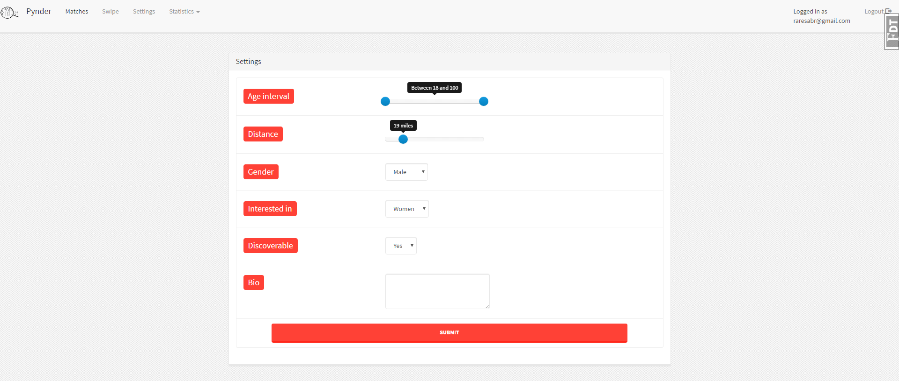

* ***Click on the settings page on the top menu***



* ***Select age interval***
  + Swipe the bar to adjust the age limit younger, older



* **Search distance**
  + You must use GPS location
  + Swipe the bar to adjust the radius in which you’ll see other users



* **Identify your gender**
  + Male
  + Female



* **Interested in**
  + Male
  + Female
  + Both



* **Discoverable**
* Choose yes if you want to be discovered by other users
* Choose no if you do not want to be discovered by other users



* **Bio**
* Add a brief profile description



Browsing through Prospects

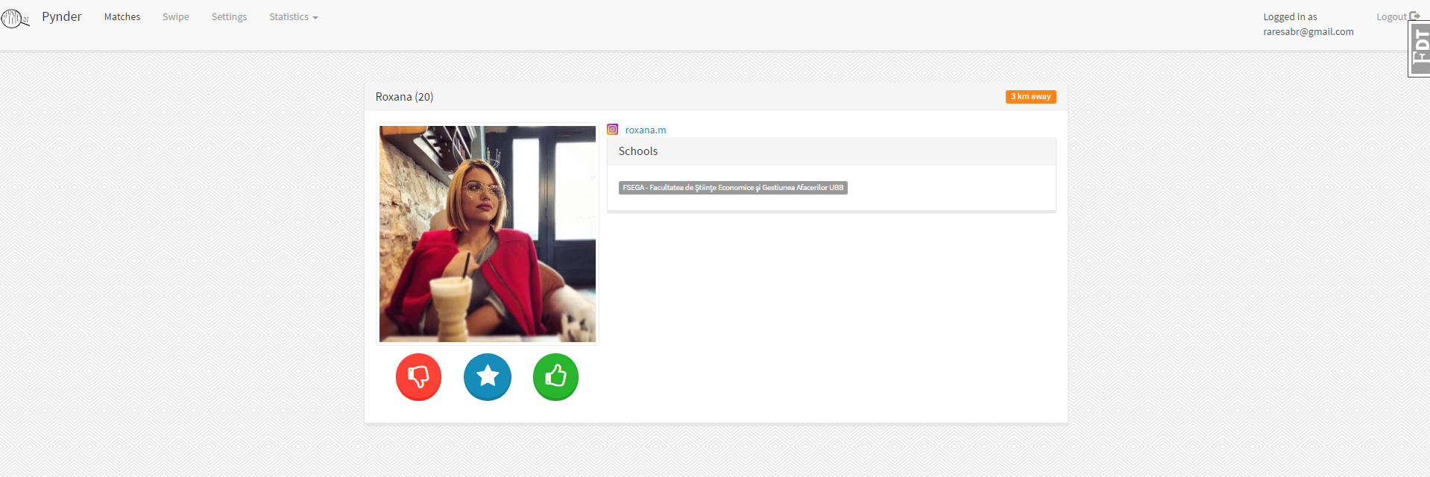

* + **Click on the swipe page on the top menu**



* + **Choose to like**
  + Press the like button



* + **Choose to dislike**
  + Press the dislike button



* + **Choose to SuperLike**
  + Press the star button



* + **Continue Browsing**
  + Pynder will continue to provide you users which matches your profile

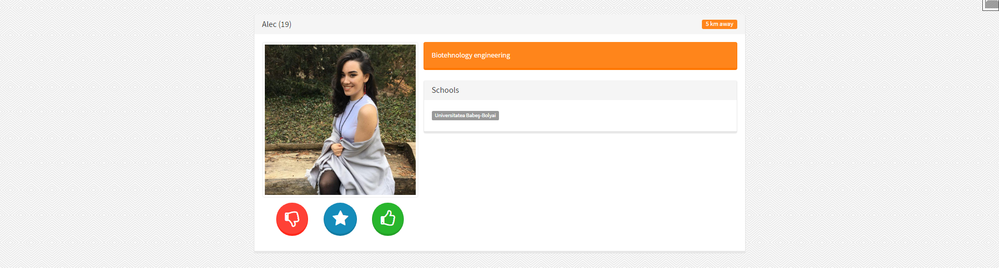

Connecting with matches

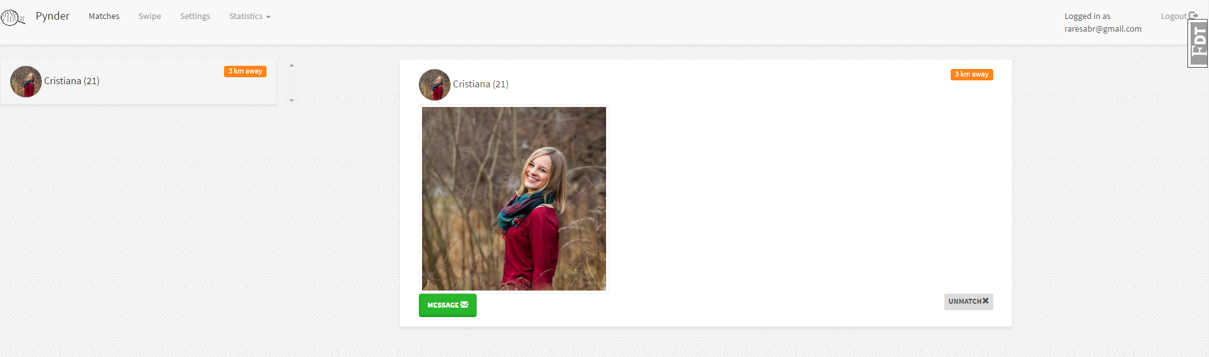

* + **Click on the swipe page on the top menu**



* + **Wait until a match has been made.**
  + If the person liked you too, you are considered a match
  + You are now able to to connect with your match

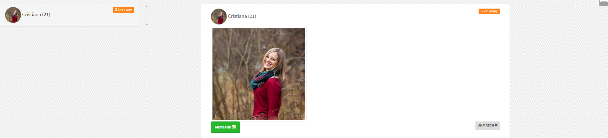

* + **Start connecting**
  + For your matches **Pynder** allows you to directly connect and communicate with them through chat function.
  + Press the message icon and get in touch.



* + **Write the first message**
  + If you are initiating contact with the other person, make sure your first message is friendly.
  + If you're a guy, avoid using emoticons. Studies have shown that emoticon used by males results in less responses.



Statistics

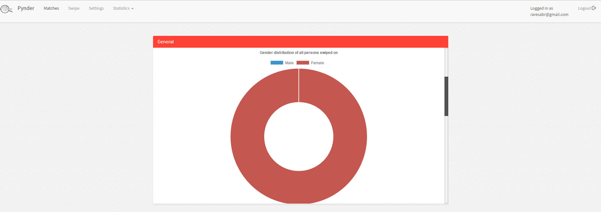

* + **Click on the swipe page on the top menu**



* + **Users can see realtime statistics based on their activity on the web-platform**

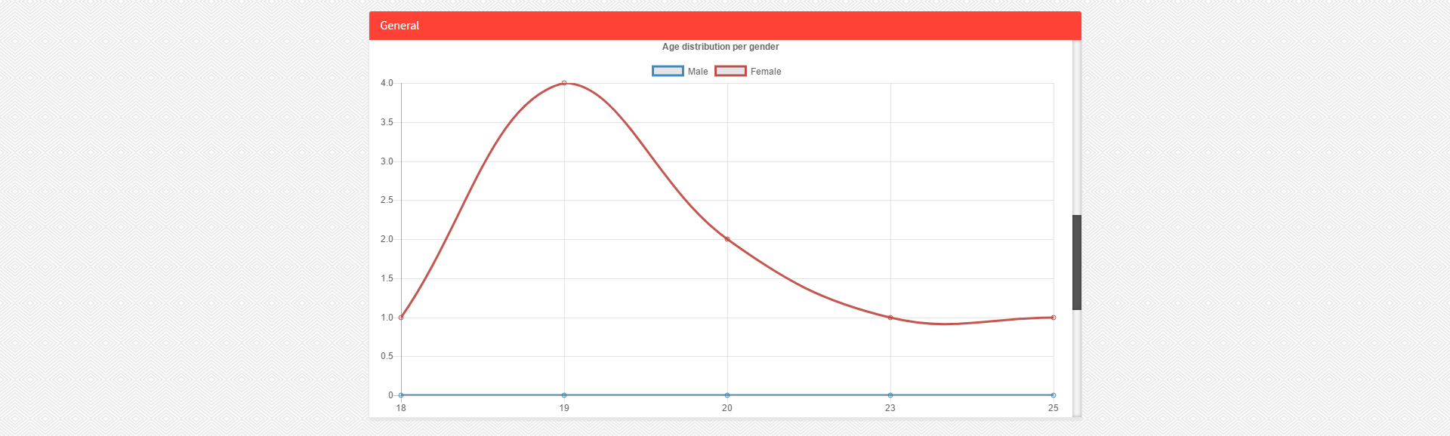

Open instagram

* + **In the browsing process one can access the instagram of any users.**